**Step1:** Create 2 Buckets one in Source region and another in destination region and in Source region bucket click on the bucket and navigate to Management and Click on Replication and Add rule.

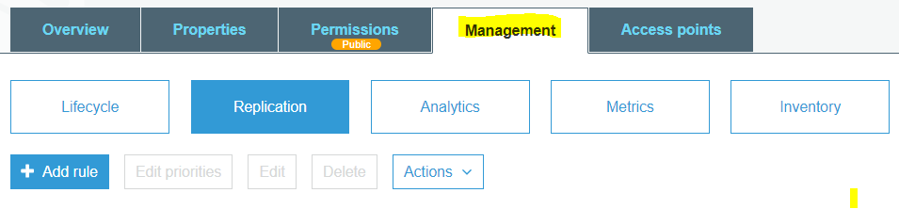

**Step2:** Select the Source bucket to replicate. We can replicate the entire bucket or objects with prefixes or tags.

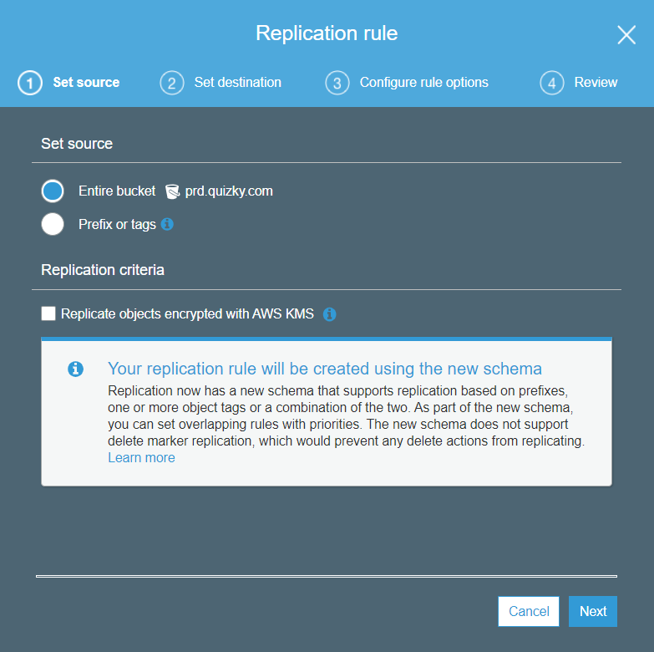

**Step 3:** Then select the Destination bucket.

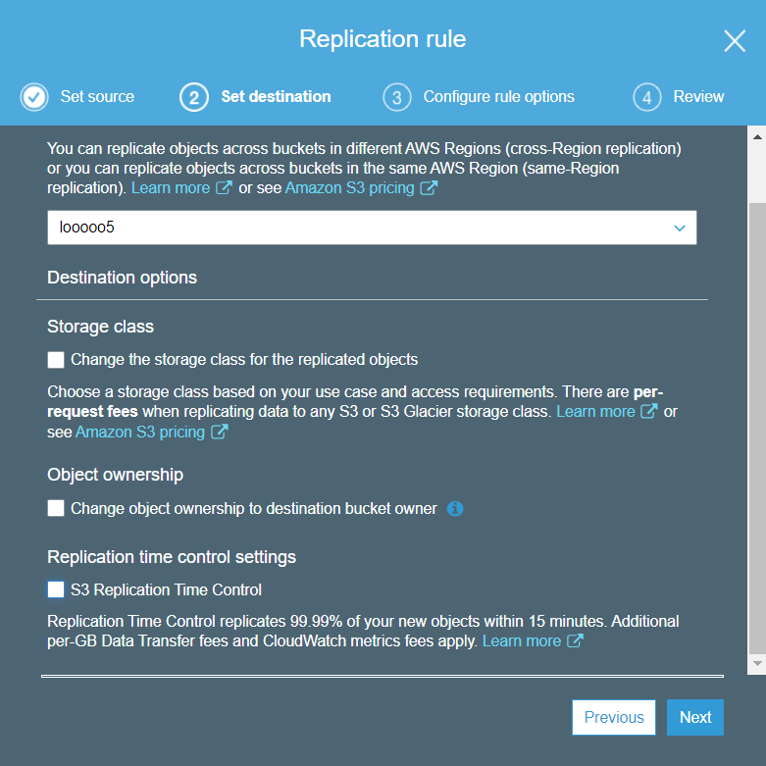

**Step4:** For destination storage class, you can choose between different S3 storage types (e.g., Standard, Standard-Infrequent Access, Reduced Redundancy)

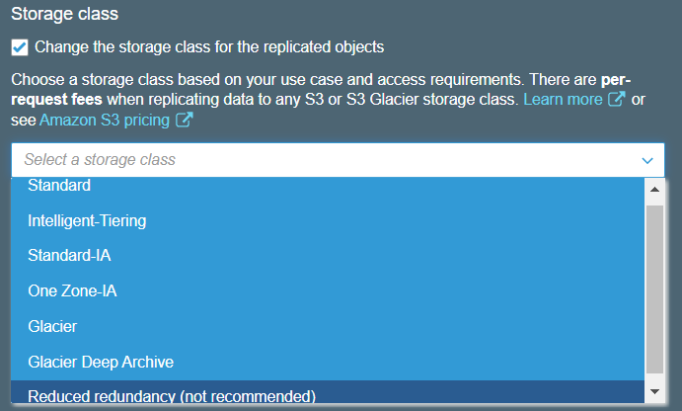

**Step 5:** We must create a Specified IAM role for replication or if we choose Create new role option AWS will automatically create a New IAM role

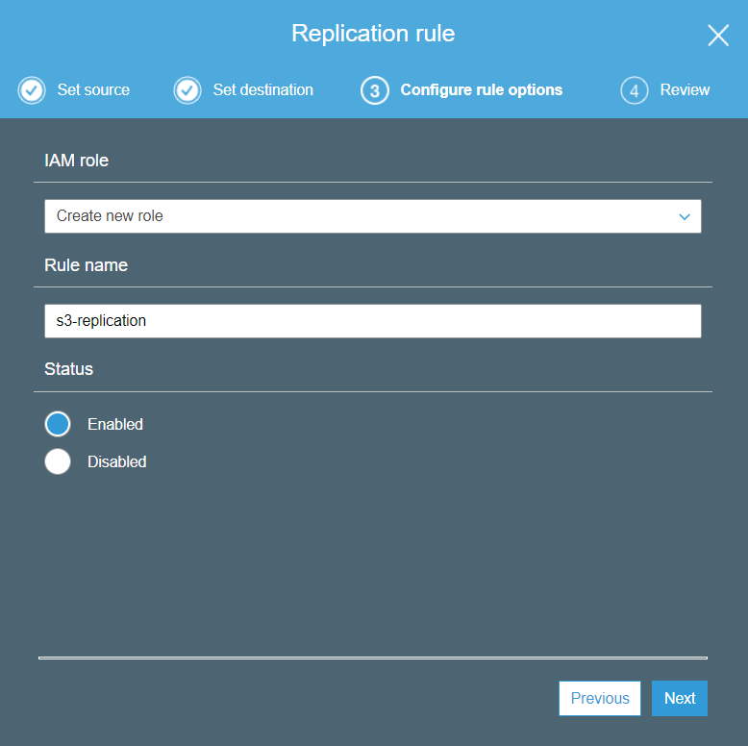

**IAM Policy:**

{

"Version": "2012-10-17",

"Statement": [

{

"Action": [

"s3:Get*",

"s3:ListBucket"

],

"Effect": "Allow",

"Resource": [

"arn:aws:s3:::<Source-bucket name>",

"arn:aws:s3:::<Source-bucket name> /*"

]

},

{

"Action": [

"s3:ReplicateObject",

"s3:ReplicateDelete",

"s3:ReplicateTags",

"s3:GetObjectVersionTagging"

],

"Effect": "Allow",

"Resource": "arn:aws:s3:::< Destination-bucket name >/*"

}

]

}

**Step 6**: Review the Replication Rule.

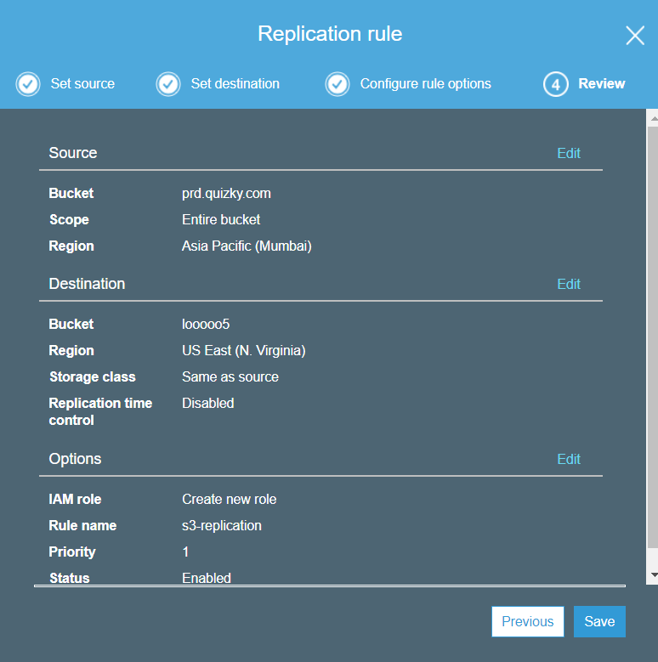

**Step 7:** After creating the replication rule you can find your rule below.

